Configure Notes/Portal Comment on Custom Entity

- Go to maker studio
- Dataverse -> Tables
- Click on New table and create custom entity
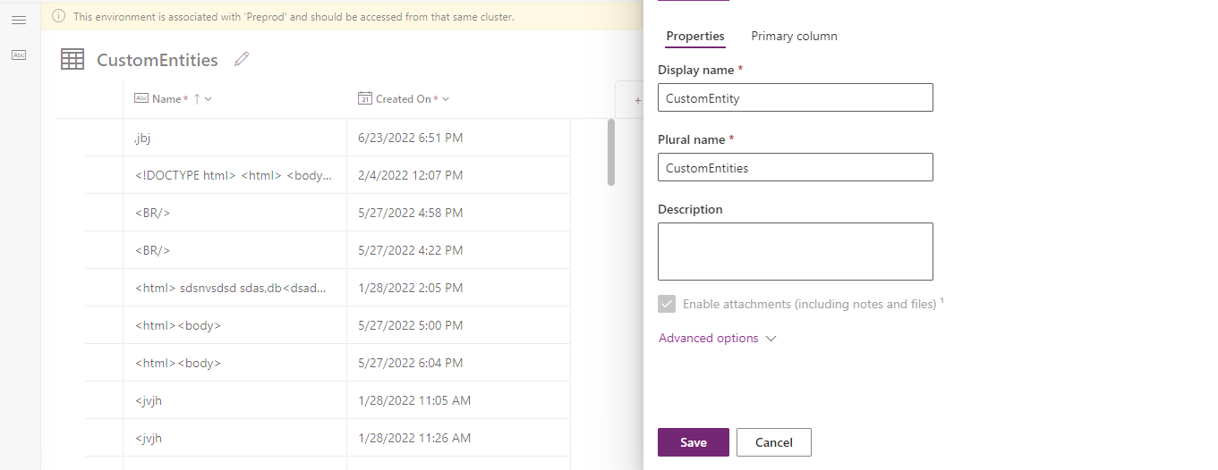
- Before adding form make sure Activities and Notes enabled for custom entity
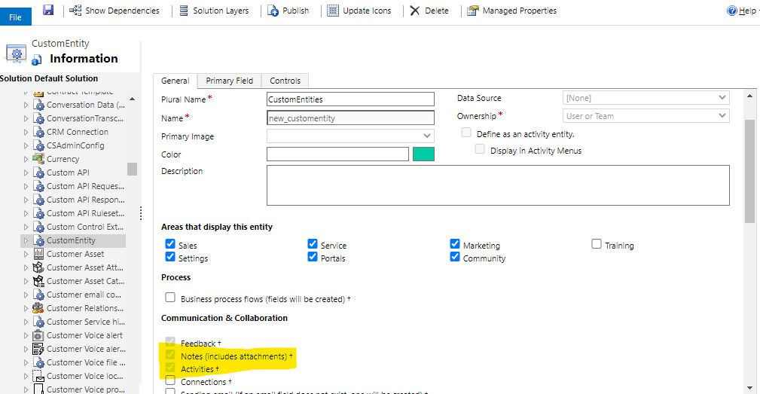
- Add 2 forms one for insert and other for Edit
- On edit form, add timeline component
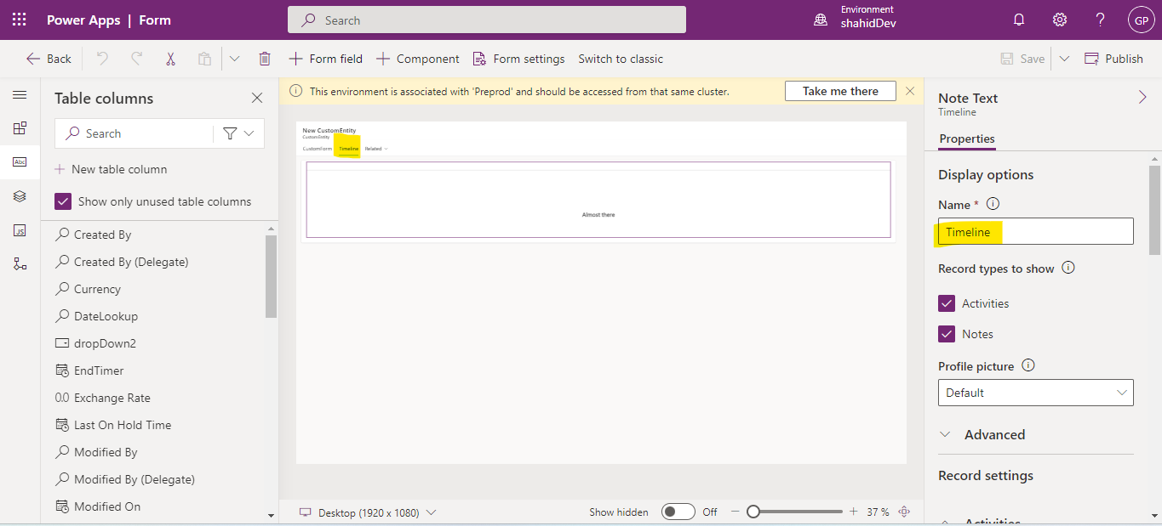
- Now configure Entity list with custom entity and enable add/edit option for entity list also configure Insert form/Edit form.
- Add metadata for timeline and notes
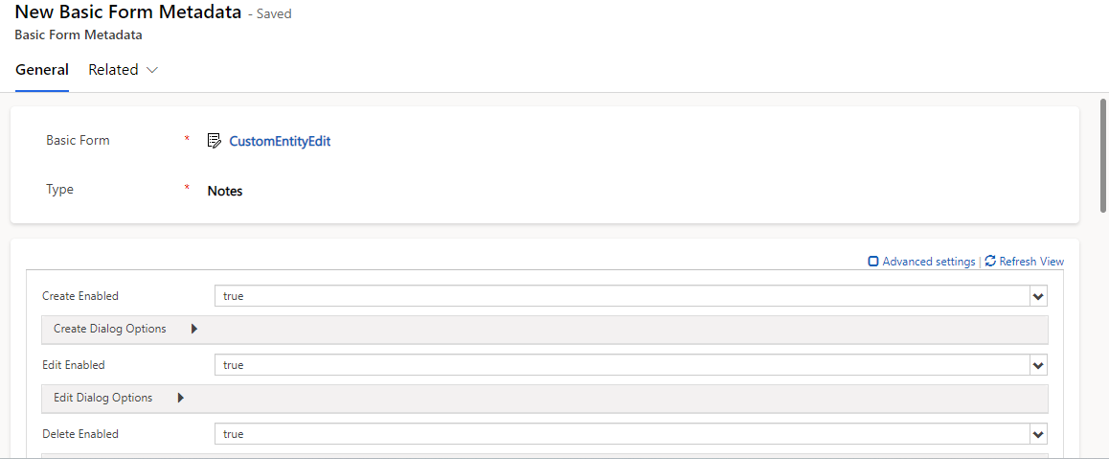
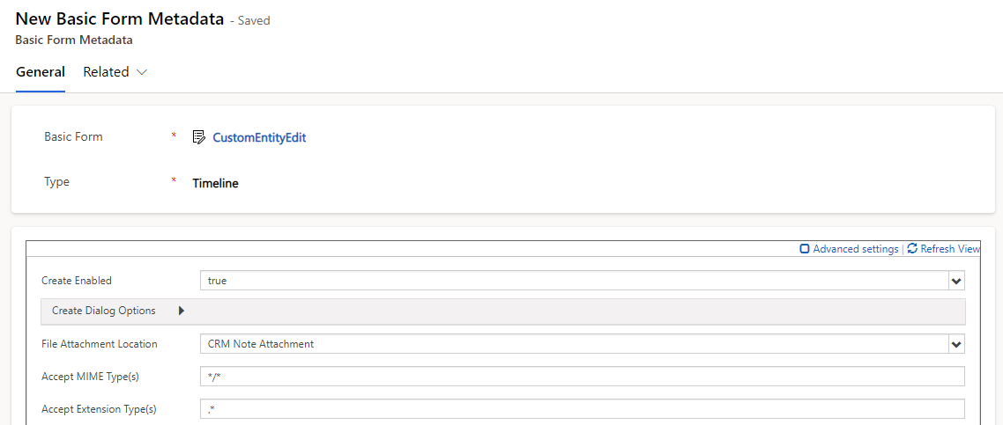
- Also Add Table Permission for adx_PortalComment and for Activity(ActivityPointer)
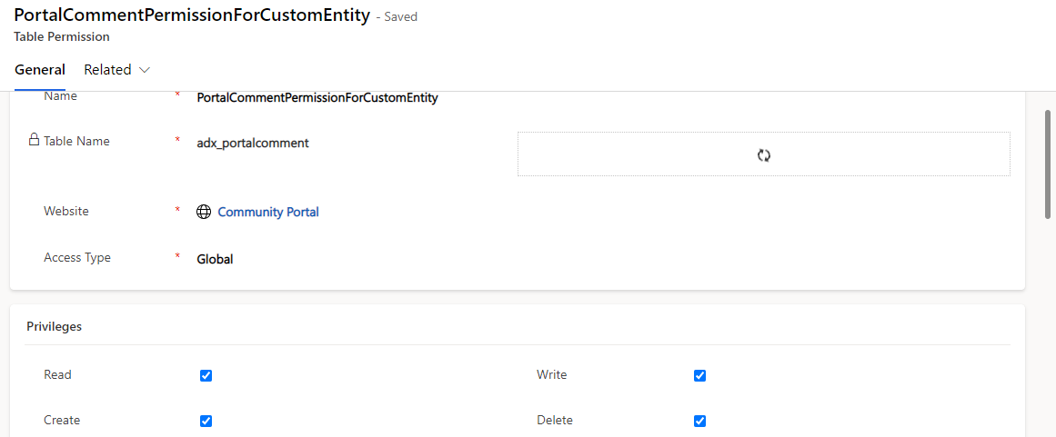
- Configure web pages for custom entity
- Enable Site Setting: Timeline/RTEEnabled=true
- Clear portal cache
- Now Go to portal -> Webpage for custom entity
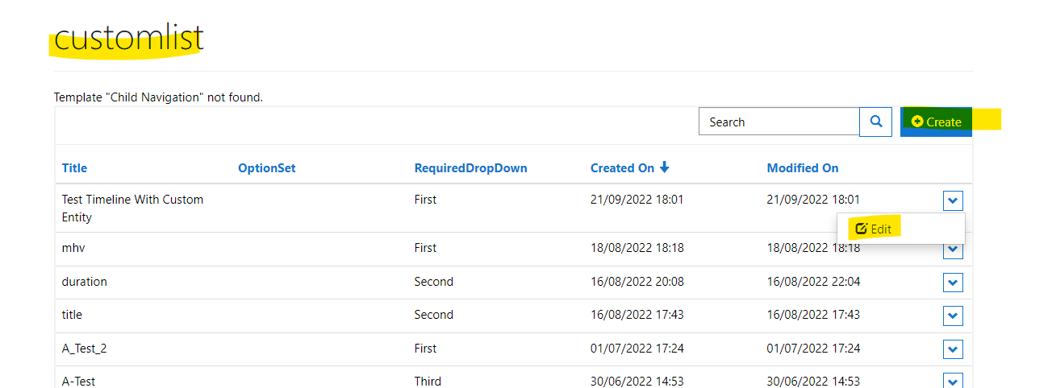
- Create record then edit -> Timeline section visible
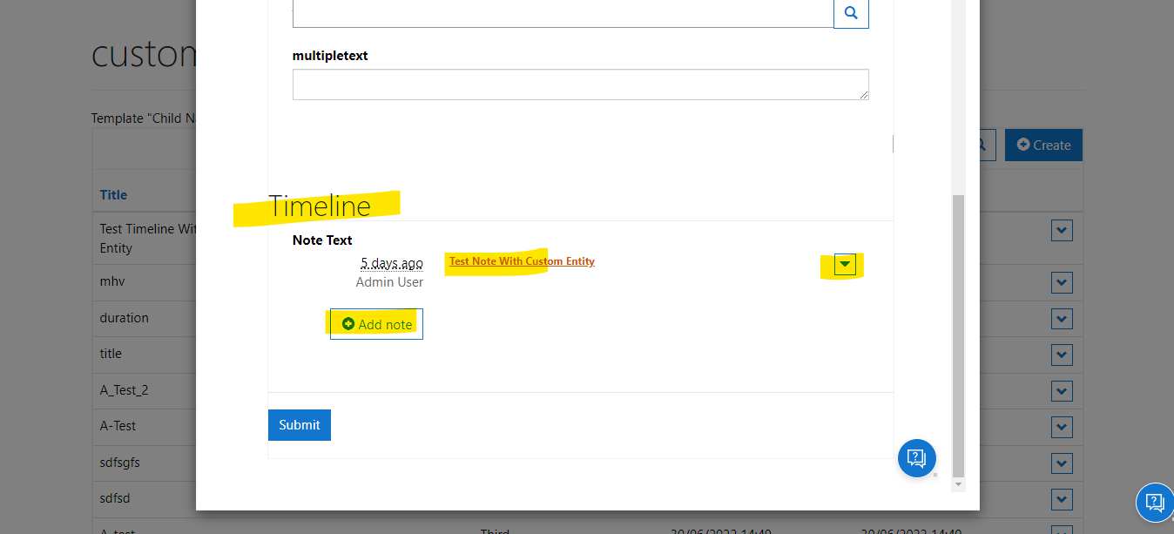
- Now perform Add/Edit/Delete note operation
- Verify notes rendered properly
- Please verify with different browser
- Also, Site Setting set to false: Timeline/RTEEnabled – false
- Clear portal cache
- Verify RTE not rendered if site setting is set to false.
- Make sure PCF control is enabled on portal and all required table permission is added for RTE, Notes

